*Salmonella* Enteritidis PT14b outbreak exercise

Bioinformatics training, interpretation of phylogenies

Prepared by the Gastrointestinal, Emerging and Zoonotic Infections department and the Gastrointestinal Bacteria Reference Unit, Public Health England, Colindale, London.

Aim of Session

To develop an understanding of how whole genome sequencing can help in the investigation of outbreaks of gastrointestinal infection.

# Format

There will be four ‘injects’ of information and data for you to interpret, modeling the developing situation as an outbreak progresses. Each inject is accompanied by questions to guide discussion within your groups. After the time allotted for each inject has expired, there will be a brief group discussion before the next inject to reiterate key points. The injects are:

1a. The first cases – 10 minutes

1b. Whole genome sequencing data on West Midlands PT14b – 20 minutes

2a. The outbreak goes national – 10 minutes

2b. Sequencing comes back on the national outbreak – 20 mins

# Learning objectives

By the end of this exercise participants should:

1. Understand the extra value of WGS based typing over traditional typing techniques and the epidemiological implications of this.
2. Be able to interpret phylogenetic trees in the context of GI outbreaks.
3. Have reflected on the impact of WGS on the practice of epidemiology.

# Summary

This scenario is based on a national outbreak of *Salmonella* Enteritidis PT14b. However, this is the Hollywood remake of the British original and the details vary from reality.

This scenario provides:

* Experience interpreting whole genome sequencing data in the context of an outbreak
* An opportunity to put existing typing techniques into the context of WGS
* An example of the importance of ‘time, place and person’ context in the interpretation of WGS

It also considers practical issues in the management of an outbreak including communication, data management, roles and responsibilities and the complexities of national outbreak investigations.

# Inject 1a: The first cases

Allow approximately 10 minutes

It is Monday 9th June 2014. The previous week the national reference lab received a phone call from a hospital reporting an unusual number of *Salmonella* Enteritidis

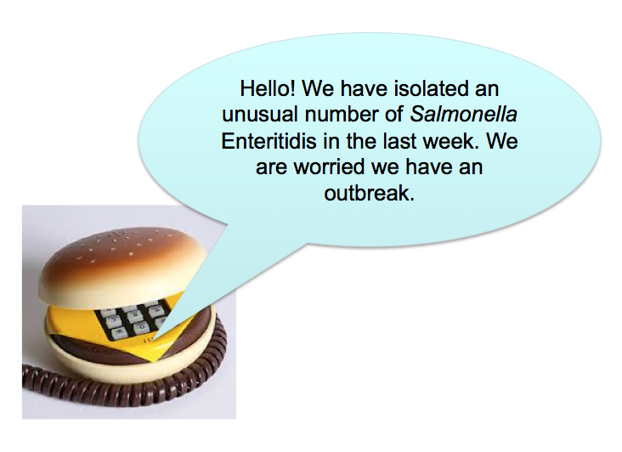

Sure enough, come Monday morning, the West Midlands cases trigger an exceedance (see Fig 1, 2, Table 1).

## Macintosh HD:Users:flashton:Desktop:Screen Shot 2015-03-04 at 16.41.41.png

### Figure 1: Exceedance report showing increase in PT14b

## Macintosh HD:Users:flashton:Desktop:Screen Shot 2015-03-03 at 16.43.16.png

### Figure 2: Epidemic curve of cases reported in the exceedance of 09/06/2014

### Table 1: Line listing of patients making up the exceedance of PT14b. Hospital or community refers to whether or not the patient’s onset date is consistent with acquisition during hospital stay.

|  |  |  |  |  |  |  |
| --- | --- | --- | --- | --- | --- | --- |
| **MOLIS** | **Region** | **Sample date** | **Patient initials** | **Age** | **Hospital or community** | **Travel** |
| H142460305 | West Midlands | 03/06/2014 | LT | 2 | Community | Spain |
| H142460306 | West Midlands | 03/06/2014 | NF | 62 | Hospital | No |
| H142420777 | West Midlands | 04/06/2014 | LT | 41 | Hospital | No |
| H142460296 | West Midlands | 05/06/2014 | DA | 23 | Hospital | No |
| H142380309 | West Midlands | 05/06/2014 | AT | 58 | Hospital | No |
| H142380308 | West Midlands | 05/06/2014 | RC | 67 | Hospital | No |
| H142440690 | West Midlands | 06/06/2014 | GB | 45 | Hospital | No |
| H142480277 | West Midlands | 06/06/2014 | MH | 62 | Hospital | No |
| H142440691 | West Midlands | 06/06/2014 | BE | 87 | Hospital | No |
| H142380310 | West Midlands | 07/06/2014 | SM | 2 | Community | No |
| H142460298 | West Midlands | 07/06/2014 | BS | 62 | Hospital | No |
| H142460297 | West Midlands | 07/06/2014 | GB | 87 | Hospital | No |
| H142480275 | West Midlands | 08/06/2014 | AV | 17 | Hospital | No |
| H142480276 | West Midlands | 08/06/2014 | BC | 43 | Hospital | No |
| H142480282 | West Midlands | 09/06/2014 | HC | 90 | Hospital | No |
| H142520451 | West Midlands | 10/06/2014 | HH | 58 | Hospital | No |

## Discussion question 1a

|  |
| --- |
| 1. What further information would you like on the cases and how would you get it? 2. What action would you take? Why? 3. At this point, would you consider this as an outbreak? Why? What measures would you take because it is hospital associated? |

# Inject 1b: Whole genome sequencing data on West Midlands PT14b

Allow approximately 20 minutes

A week after the isolates making up the West Midlands exceedance are received by SRS, the sequencing data has come back from the Genomic Sequencing Unit at Colindale and has been processed through the Gastrointestinal Bacteria Reference Unit pipeline. One of the outputs of this pipeline is a phylogenetic tree (Figure 3), which places isolates into the imputed phylogenetic context.

### Macintosh HD:Users:flashton:Desktop:Screen Shot 2015-03-05 at 16.56.31.png

### Figure 3: Phylogenetic tree of *Salmonella* Enteritidis

## Discussion question 1b

|  |
| --- |
| Review the information, what conclusions can you draw?   1. Are all the PT14b isolates from the exceedance closely related? 2. What does the WGS tell you about the cases in the hospital? 3. How many SNPs is the outbreak from the most closely related other isolate? What does this suggest about the outbreak? |

# Inject 2a: Outbreak goes national

Allow approximately 10 minutes

More than a month after the initial West Midlands event and the outbreak has gone national! Over a 3 week period a large number of cases occur in Cheshire & Merseyside and Hampshire & Isle of Wight & Dorset. The clusters in Cheshire & Merseyside and Hampshire & Isle of Wight & Dorset are associated with Chinese restaurants.

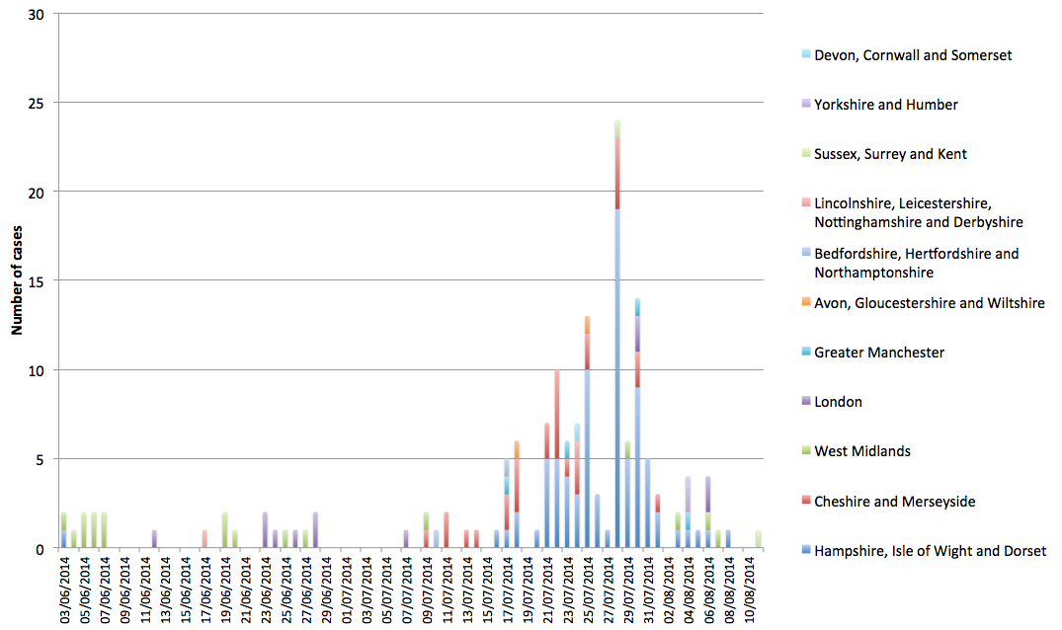

### Figure 4: Epidemic curve of outbreak up to present

### Table 2: Summary of the number of cases in different regions

|  |  |
| --- | --- |
| **PHE centre** | **Total number of cases** |
| Hampshire, Isle of Wight and Dorset | 82 |
| Cheshire and Merseyside | 29 |
| West Midlands | 18 |
| London | 12 |
| Greater Manchester | 4 |
| Avon, Gloucestershire and Wiltshire | 2 |
| Bedfordshire, Hertfordshire and Northamptonshire | 2 |
| Lincolnshire, Leicestershire, Nottinghamshire and Derbyshire | 2 |
| Sussex, Surrey and Kent | 2 |
| Yorkshire and Humber | 2 |
| Devon, Cornwall and Somerset | 1 |

# Inject 2b: Sequencing comes back on the national outbreak

Allow approximately 20 minutes

Seven to ten days after the isolates are received by Colindale, we get the sequencing results back and we generate a new phylogeny based on all the isolates (Fig 5).

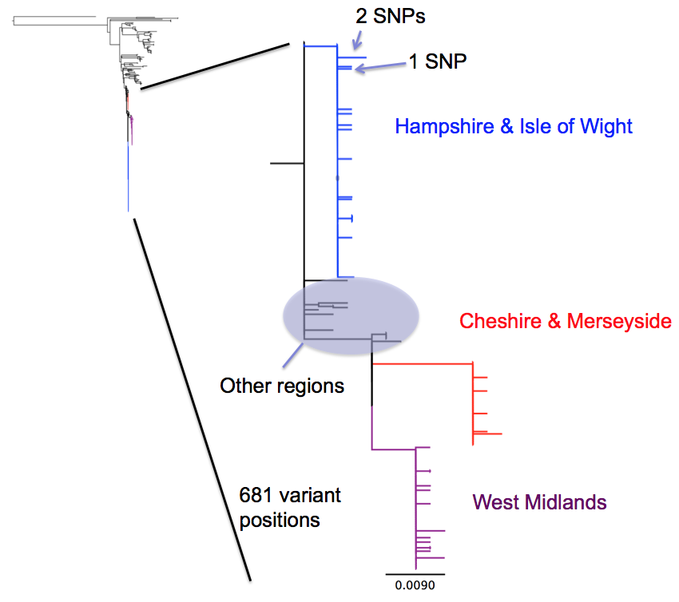

### Figure 5: Phylogenetic tree of national outbreak

### Discussion question 2b

|  |
| --- |
| 1. What is your interpretation of the sequencing results? How does it relate to what you predicted the sequencing results to look like? 2. What could explain the differences between the geographically separated outbreaks? 3. Would you say this is a single outbreak? |

Appendix 1

Glossary of terms

* **WGS**: whole genome sequencing, determining the sequence of DNA encoded by an organism.
* **SNP**: Single nucleotide polymorphism, the most common type of variant used in phylogenetic analyses arising from whole genome sequencing
* **Phylogenetics**: the study of evolutionary relationships among groups of organisms through study of biological macromolecules (e.g. DNA).
* **Case-case analysis**: An epidemiological method to compare cases in an outbreak to cases of similar disease who are not part of an outbreak: <http://ije.oxfordjournals.org/content/28/4/764.full.pdf?origin=publication_detail>
* **ECDC**: European Centre for Disease Prevention and Control: <http://www.ecdc.europa.eu/en/Pages/home.aspx>
* **EHO**: Environmental Health Officer: <http://www.cieh.org/professional_development/becoming_an_EHP.html>
* **Exceedance**: An automated report based on laboratory reporting of human isolates which lists organisms for which more isolates have been reported in the previous week than would be expected based on historical data.
* **FSA**: Food Standards Agency: <http://www.food.gov.uk/>
* **FWE**: Food, Water and Environmental Microbiology Services:

<http://www.hpa.org.uk/ProductsServices/MicrobiologyPathology/SpecialistMicrobiologyServices/FoodWaterEnvironmentalMicrobiologyServices/>

* **GDW**: Gastro Data Warehouse: A PHE system containing laboratory results for isolates of gastrointestinal infections: <https://bioinfosecure.phe.org.uk/gdw>
* **GEZI**: Gastrointestinal, Emerging and Zoonotic Infections department, PHE
* **GBRU:** Gastrointestinal Bacteria Reference Unit
* **OCT**: Outbreak Control Team: Set up to coordinate outbreak investigations.
* **PCR**: Polymerase chain reaction: Method of amplifying a segment of DNA used to determine presence of a particular gene.
* **MLVA**: Multiple-locus Variable Number Tandem Repeat Analysis: A method used to perform molecular typing. It utilizes the naturally occurring variation in the number of tandem repeated DNA sequences found in different loci in the genome. <http://www.cdc.gov/pulsenet/pathogens/mlva.html>
* **PT**: Phage type: A method of discriminating within the VTEC O157 serogroup based on how isolates react to bacteriophages.
* **Trawl**: A very detailed questionnaire used to inform hypothesis generation.
* **SRS**:Salmonella Reference Service, the national reference lab for *Salmonella*
* **Clade**: a monophyletic group, may be very closely related or more distantly related.

##### Appendix 2

##### Macintosh HD:Users:flashton:Desktop:Screen Shot 2015-03-16 at 10.12.16.png

##### Supp figure 1: A nomenclature for discussing the genetic relatedness of bacteria. Maiden *et al*., Nature Reviews Microbiology 11, 728–736 (2013) doi:10.1038/nrmicro3093

##### Sources of Information - Expert advice on outbreak investigation and epidemiology

* Your colleagues!
* Public Health England Field Epidemiology Services and Local Health Protection Units
* Gastrointestinal Bacteria Reference Unit, Colindale

##### PHE Databases

* GDW: <https://bioinfosecure.phe.org.uk/gdw>

##### Other sources of information:

* Youtube video of a presentation on the Salmonella WGS work at PHE: <http://bit.ly/1M8PZWm>
* List of WGS papers that are relevant to public health microbiologists and epidemiologists: <http://bit.ly/1ALLk6l>